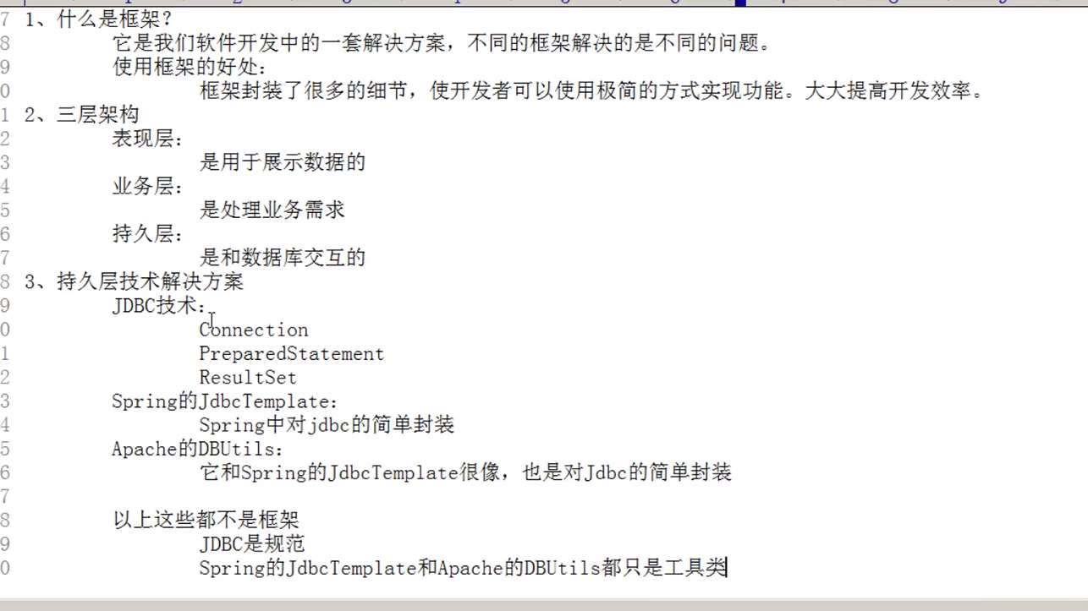

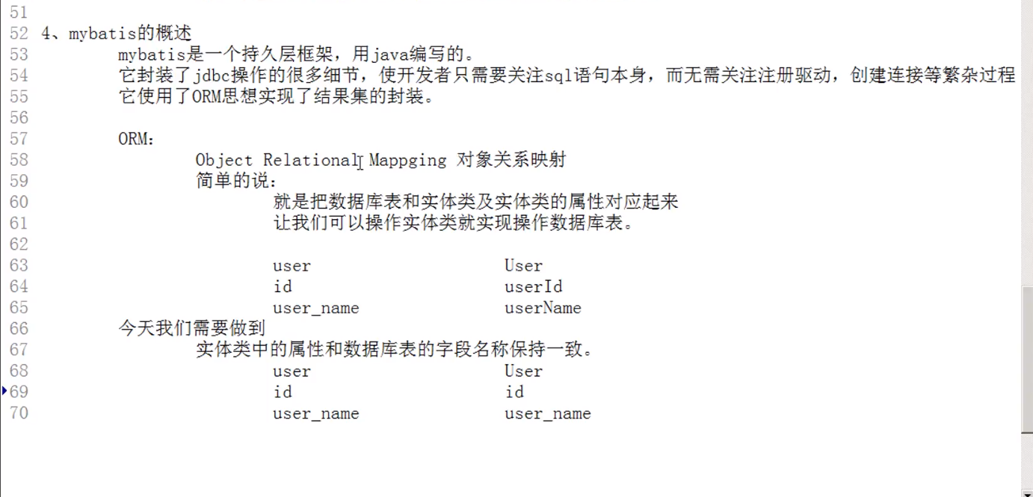

1. mybatis工程搭建
2. 创建maven工程引入相关坐标
3. 编写UseMapper.java UserMapper.xml

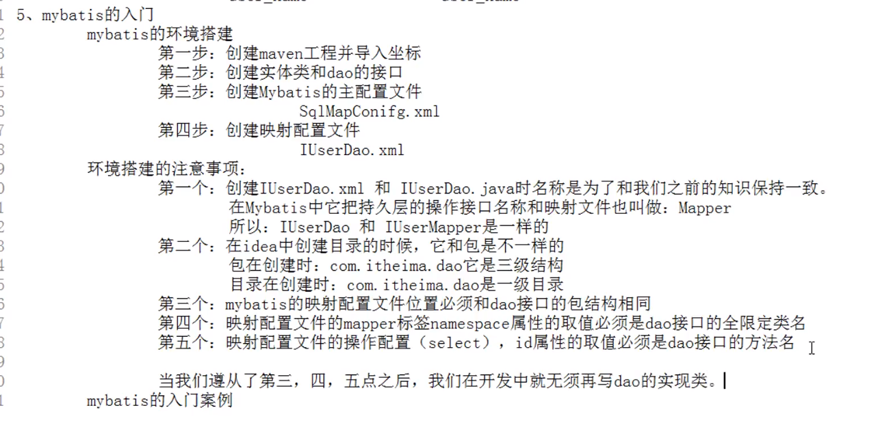

|  |
| --- |
| **package** com.igeek.ssm.mapper;  **import** com.igeek.ssm.domain.User;  **import** java.util.List;  **public interface** UserMapper {   **public** List<User> selectAllUsers();   **public** User selectUserByUid(Integer uid);  } |
| *<?***xml version="1.0" encoding="UTF-8"** *?>* **<!DOCTYPE mapper  PUBLIC "-//mybatis.org//DTD Mapper 3.0//EN"  "http://mybatis.org/dtd/mybatis-3-mapper.dtd"*>*** <**mapper namespace="com.igeek.ssm.mapper.UserMapper"**>  *<!--查询所有 id是dao的方法名称 -->* <**select id="selectAllUsers" resultType="com.igeek.ssm.domain.User"**>  select *\** from user;  </**select**>  </**mapper**> |

二、